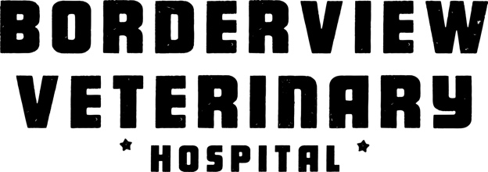

COVID-19 Update
March 13, 2020
Our priority is the wellbeing of our clients and staff. Like everyone, we are closely monitoring the reports of COVID-19. We take our lead from the Niagara Region Public Health and the College of veterinarians of Ontario (CVO), who are in constant consultation with their federal and provincial counterparts.
Our practice is continuing as scheduled. However, we are evaluating the situation as it is quickly evolving. Should the hospital need to adjust our hours or close we will inform all our clients on our website and social media. We ask that you have patience with us as we may have to reduced staff to accommodate with the government regulations at this time.
If you have any questions please call the hospital at 905-871-4366.
For those who have an underlying medical condition, are ill or have recently returned from a foreign destination we asked that you stay home for the safety and welling being of other clients and our staff.
WHAT WE’RE DOING
Our hospital is cleaned multiple times daily by our staff with disinfectant.
WHAT YOU CAN DO
• Stay at home if you are feeling sick.
• Cover your cough or sneeze with a tissue, then throw the tissue in the trash.
• Wash your hands frequently with soap and hot water.
• Avoid touching your face, mouth, and eyes.
• Practice simple social distancing strategies from those who are sick, such as verbal salutations instead of handshakes or hugs
Also please leave non pertinent items, such as drink containers in your vehicle.
Please check with us for further updates. Health Canada: COVID-19 Affected Areas List
<https://www.canada.ca/…/h…/covid-19-affected-areas-list.html

